METHOD
Design and Stimulus Development
A 3 X 2 between-subjects experimental study was conducted to investigate the proposed hypotheses. The first independent variable, “celebrity endorser’s experience,” related to the endorsed cause varied at three levels: (1) self, (2) family, and (3) none, which represent the type of celebrity and experience association. The second independent variable, “type of association between the celebrity endorser and the nonprofit organization,” had two levels, with the celebrity being either a founder or a spokesperson. Six scenarios and advertisements representing the experimental conditions were developed as stimuli.
The celebrities and the stories in the scenarios and the accompanying ads were all fictitious and created solely for study purposes. In the scenarios, colorectal cancer, associated with a high-fat, low-fiber diet and red meat, was chosen as the cause for the study, due to the fact that the disease is presently the third most common form of cancer and the second leading cause of cancer-related death in the U.S. Although most cases occur after age 50, there are growing concerns concerning hereditary syndromes in which the cancer can develop in young people, and that their dietary choices may increase their risk of cancer at any age. In addition, colorectal cancer is not gender specific, so both male and female subjects would find it to be relevant.
A fictitious female celebrity, Catherine Meyer, was presented as either the founder or spokesperson of Colorectal Cancer Society (CCS), a fictitious foundation for colorectal cancer. The six versions of experimental stimuli were prepared in the forms of a scenario which provided background information and a corresponding print advertisement that featured a picture of the celebrity and a headline which read: “Are you the picture of health?” Information on the cancer was placed at the bottom of the advertisement. The executional formats and layouts were identical across the six experimental conditions. The only differences were the manipulations of the two independent variables, the celebrity’s mention of personal reasons for endorsing the cause and the celebrity’s role in relation to the foundation.
Participants and the Data Collection Procedure
A total of 164 undergraduate students (41 males and 123 females) at a major Southwestern university participated in this study. Subjects were told that the purpose of the study was to understand individual reactions to a celebrity endorsing a socially worthy cause. Participants were randomly assigned to one of the six experimental conditions. Upon consenting to take part in the Web-based study, participants were asked to read their given scenario, view the corresponding advertisement, and then fill out the questionnaire, which consisted of measures of celebrity-cause congruence, attributions of celebrity motives, perceived celebrity credibility, as well as attitudes toward the celebrity, the ad, and the non-profit organization, and resultant donation and cancer screening intents along with involvement with the cause.
Measures
Celebrity-Cause Congruence. The congruence between celebrity and cause was measured on a four-item, seven-point scale anchored by not consistent/consistent, not a good fit/a good fit, not congruent/congruent, and not compatible/compatible. One item (not consistent/consistent) was added into Rifon, Choi, Trimble, and Li’s (2004) three-item, seven-point scale (not a good fit/a good fit, not congruent/congruent, and not compatible/compatible).
Celebrity Motive. Participants were asked to respond to statements concerning the reasons for the celebrity’s appearance in the ad for the foundation. In order to assess participants’ attributions to the celebrity’s altruistic and self-serving motives, an eight-item Likert scale, ranging from 1 (extremely unlikely) to 7 (extremely likely), was created for this study. First, the self-serving motives were measured via five items, including celebrity’s concern for public attention and exposure, and her concern for public image, including image improvement, image enhancement, and the creation of positive images. Second, the participants’ perception of the celebrity’s altruistic motives were gauged via three statements, which included the celebrity’s concern about the cause, belief in the cause, and concern about public health in general.
Celebrity Credibility. Ohanian’s (1990) 15-item semantic differential scale was used to measure the celebrity endorser’s perceived credibility on three dimensions: trustworthiness, expertise, and attractiveness. Each five-item, seven-point scale was anchored by undependable/dependable, dishonest/honest, unreliable/reliable, insincere/sincere, and untrustworthy/trustworthy in the dimension of trustworthiness, by inexpert/expert, inexperienced/experienced, unknowledgeable/knowledgeable, unqualified/qualified, and unskilled/skilled in the expertise dimension (Cronbach’s α = .88), and by unattractive/attractive, not classy/classy, ugly/beautiful, plain/elegant, and not sexy/sexy in the attractiveness dimension.
Attitudes toward Celebrity, Ad, and Foundation. Based on MacKenzie and Lutz’s (1989) measurement for attitudes, subjects were asked to rate their overall impression of the celebrity, the advertisement, and the non-profit organization on a three-item, seven-point bipolar adjective scale which was anchored by good/bad, favorable/unfavorable, and pleasant/unpleasant.
Donation and Screening Intentions. Participants’ intentions to donate to the foundation and perform screening for the cancer were assessed via a three-item, seven-point bipolar scale, which was anchored by “very likely/very unlikely,” “probable/improbable,” and “possible/impossible” (Yi, 1990).
Involvement with Cause. Based on Flora and Maibach’s (1990) measurement for concerns about contracting AIDS, involvement was measured with a four-item, Likert scale, ranging from 1 (extremely unlikely) to 7 (extremely likely). The specific statements were: “I think colorectal cancer is a great deal,” “I consider myself at risk for developing colorectal cancer,” “Colorectal cancer is a personally relevant topic for me,” and “I actively seek the most recent information about colorectal cancer.”

Questionnaires

SECTION 1
For the following questions, please indicate how you feel about the ad you just saw and the foundation, the Colorectal Cancer Society, by selecting one of each bipolar adjective pair.
The Ad
Bad | _____:_____:_____:_____:_____:_____:_____  1 2 3 4 5 6 7 | Good
Unfavorable | _____:_____:_____:_____:_____:_____:_____  1 2 3 4 5 6 7 | Favorable
Pleasant | _____:_____:_____:_____:_____:_____:_____  1 2 3 4 5 6 7 | Unpleasant

The Foundation, the Colorectal Cancer Society

Bad | _____:_____:_____:_____:_____:_____:_____  1 2 3 4 5 6 7 | Good
Unfavorable | _____:_____:_____:_____:_____:_____:_____  1 2 3 4 5 6 7 | Favorable
Unpleasant | _____:_____:_____:_____:_____:_____:_____  1 2 3 4 5 6 7 | Pleasant

SECTION 2

How likely would it be that you consider donating money to the foundation, the Colorectal Cancer Society? For the following questions, please click the proper one consistent with your opinion.

Very unlikely | _____:_____:_____:_____:_____:_____:_____  1 2 3 4 5 6 7 | Very likely
Improbable | _____:_____:_____:_____:_____:_____:_____  1 2 3 4 5 6 7 | Probable
Impossible | _____:_____:_____:_____:_____:_____:_____  1 2 3 4 5 6 7 | Possible

How likely would it be that you consider getting screened for colorectal cancer? For the following questions, please click the proper one consistent with your opinion.
Very unlikely | _____:_____:_____:_____:_____:_____:_____  1 2 3 4 5 6 7 | Very likely
Improbable | _____:_____:_____:_____:_____:_____:_____  1 2 3 4 5 6 7 | Probable
Impossible | _____:_____:_____:_____:_____:_____:_____  1 2 3 4 5 6 7 | Possible

SECTION 3

How do you feel about the celebrity, Catherine Meyer, who appeared in the ad you just saw? Please click the button that reflects your opinion.

Unattractive | _____:_____:_____:_____:_____:_____:_____  1 2 3 4 5 6 7 | Attractive
Not classy | _____:_____:_____:_____:_____:_____:_____  1 2 3 4 5 6 7 | Classy
Ugly | _____:_____:_____:_____:_____:_____:_____  1 2 3 4 5 6 7 | Beautiful
Plain | _____:_____:_____:_____:_____:_____:_____  1 2 3 4 5 6 7 | Elegant
Not sexy | _____:_____:_____:_____:_____:_____:_____  1 2 3 4 5 6 7 | Sexy
Undependable | _____:_____:_____:_____:_____:_____:_____  1 2 3 4 5 6 7 | Dependable
Dishonest | _____:_____:_____:_____:_____:_____:_____  1 2 3 4 5 6 7 | Honest
Unreliable | _____:_____:_____:_____:_____:_____:_____  1 2 3 4 5 6 7 | Reliable
Insincere | _____:_____:_____:_____:_____:_____:_____  1 2 3 4 5 6 7 | Sincere
Untrustworthy | _____:_____:_____:_____:_____:_____:_____  1 2 3 4 5 6 7 | Trustworthy
Not an expert | _____:_____:_____:_____:_____:_____:_____  1 2 3 4 5 6 7 | Expert
Inexperienced | _____:_____:_____:_____:_____:_____:_____  1 2 3 4 5 6 7 | Experienced
Unknowledgeable | _____:_____:_____:_____:_____:_____:_____  1 2 3 4 5 6 7 | Knowledgeable
Unqualified | _____:_____:_____:_____:_____:_____:_____  1 2 3 4 5 6 7 | Qualified
Unskilled | _____:_____:_____:_____:_____:_____:_____  1 2 3 4 5 6 7 | Skilled

Bad | _____:_____:_____:_____:_____:_____:_____  1 2 3 4 5 6 7 | Good
Unfavorable | _____:_____:_____:_____:_____:_____:_____  1 2 3 4 5 6 7 | Favorable
Pleasant | _____:_____:_____:_____:_____:_____:_____  1 2 3 4 5 6 7 | Pleasant

SECTION 4
How likely is it that each of the following statements about the reasons of Catherine Meyer's appearance in the ad for the Colorectal Cancer Society is true? Please click the answers that most reflect your opinions.
Extremely Extremely
Unlikely Likely
1. Catherine Meyer agreed to the ad because of the characteristics of colorectal cancer. | _____:_____:_____:_____:_____:_____:_____  1 2 3 4 5 6 7
2. Catherine Meyer endorses the cause for the tax write-off. | _____:_____:_____:_____:_____:_____:_____  1 2 3 4 5 6 7
3. Catherine Meyer bolsters the cause to receive attention. | _____:_____:_____:_____:_____:_____:_____  1 2 3 4 5 6 7
4. Catherine Meyer appears in the ad because she cares about colorectal cancer. | _____:_____:_____:_____:_____:_____:_____  1 2 3 4 5 6 7
5. Catherine Meyer becomes associated with the cause to improve her image. | _____:_____:_____:_____:_____:_____:_____  1 2 3 4 5 6 7
6. Catherine Meyer does the ad only because it creates a positive celebrity image. | _____:_____:_____:_____:_____:_____:_____  1 2 3 4 5 6 7
7. Catherine Meyer supports the cause because it is consistent with her image. | _____:_____:_____:_____:_____:_____:_____  1 2 3 4 5 6 7
8. Catherine Meyer does the ad because she really believes in the importance of raising awareness of colorectal cancer. | _____:_____:_____:_____:_____:_____:_____  1 2 3 4 5 6 7
9. Catherine Meyer appears in the ad only because of her self-satisfaction. | _____:_____:_____:_____:_____:_____:_____  1 2 3 4 5 6 7
10. Catherine Meyer appears in the ad to enhance her public image. | _____:_____:_____:_____:_____:_____:_____  1 2 3 4 5 6 7
11. Catherine Meyer does the ad because ultimately she cares about public health. | _____:_____:_____:_____:_____:_____:_____  1 2 3 4 5 6 7
12. Catherine Meyer appears in the ad to get exposure. | _____:_____:_____:_____:_____:_____:_____  1 2 3 4 5 6 7

SECTION 5
What do you think about the celebrity, Catherine Meyer, promoting colorectal cancer awareness? For the following questions, please click the proper one consistent with your opinion.
Not consistent | _____:_____:_____:_____:_____:_____:_____  1 2 3 4 5 6 7 | Consistent
Not a good fit | _____:_____:_____:_____:_____:_____:_____  1 2 3 4 5 6 7 | A good fit
Not congruent | _____:_____:_____:_____:_____:_____:_____  1 2 3 4 5 6 7 | Congruent
Not compatible | _____:_____:_____:_____:_____:_____:_____  1 2 3 4 5 6 7 | Compatible

How likely is it that each of the following statements about your concerns about colorectal cancer is true? For the following questions, please click the proper one consistent with your opinion.
Extremely Extremely
Unlikely Likely
1. I think about colorectal cancer a great deal. | _____:_____:_____:_____:_____:_____:_____  1 2 3 4 5 6 7
2. I consider myself at risk of developing colorectal  cancer. | _____:_____:_____:_____:_____:_____:_____  1 2 3 4 5 6 7
3. Colorectal cancer is a personally relevant topic  for me. | _____:_____:_____:_____:_____:_____:_____  1 2 3 4 5 6 7
4. I actively seek the most recent information about colorectal cancer. | _____:_____:_____:_____:_____:_____:_____  1 2 3 4 5 6 7

SECTION 6

In order to effectively evaluate the survey responses, please answer the following general information. Please remember all of your answers remain strictly confidential.

Gender: Male Female

Age : ________

Year in School : Freshmen Sophomore Junior Senior

Major : ________

Ethnicity: Caucasian Black Latin Asian Other

Personal Involvement with the Colorectal Cancer:
Have you ever had colorectal cancer? Or is there anyone around you who has been diagnosed with the colorectal cancer? If true, please check the all that apply.

1) Myself
2) Parents
3) Siblings
4) Relatives
5) Friends
6) Others (Please specify) )

Experimental Stimuli
The Myself-Founder Condition  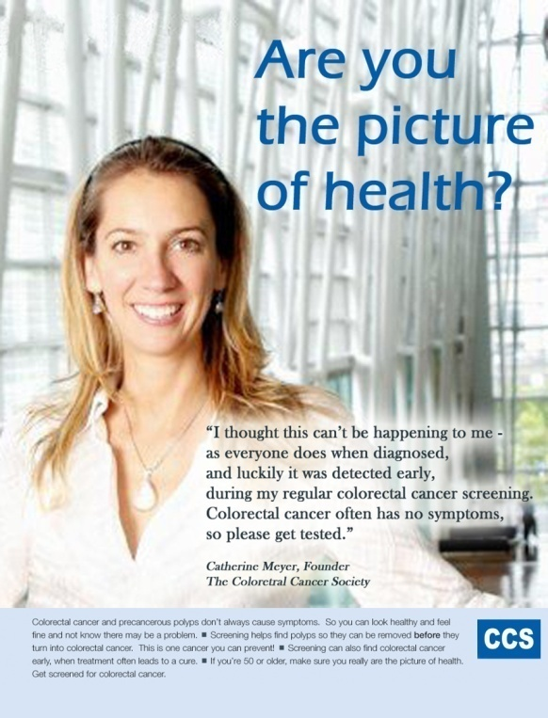 | The None-Founder Condition  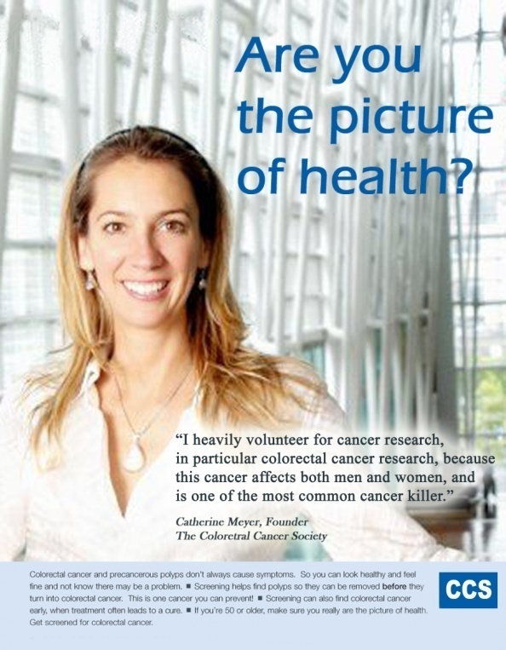
The Myself-Spokesperson Condition  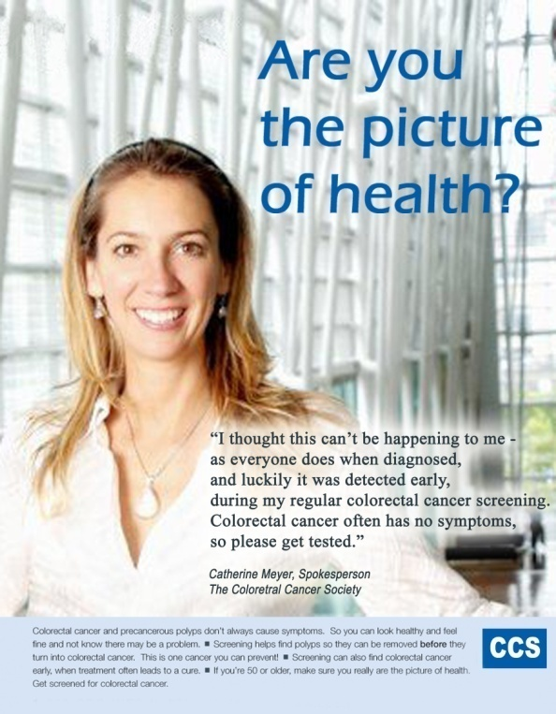 | The None-Spokesperson Condition  